OpenCV Image Processing Lab
AI BASED IMAGE PROCESSING AND EDITING APPLICATION

Project Documentation | Diploma in Artificial Intelligence and Machine Learning | GTTC Belagavi

1. Introduction :-
An AI Photo Editor is a simple application designed to edit and improve images easily. It uses Python and OpenCV to perform various image-processing operations such as brightness,contrast, sharpening, filtering,and resizing. The project reduces manual effort and saves time by providing multiple editing features in one place. It is designed with a simple and user-friendly interface, making photo editing easy for beginners.

- Problem Statement :-
Traditional photo editing can be complex, time-consuming, and difficult for beginners. There is a need for a simple application that provides common editing features in one place.

- Objectives :-
- To develop a simple and user-friendly photo editor.
- To apply different image-processing operations.
- To reduce manual effort and editing time.
- To provide quick preview and editing results.

- Technologies Used :-

- Backend : Python, Flask
- Frontend : HTML,CSS,OpenCV
- ImageProcessing : OpenCV
- Image Handling : Pillow
- Numerical Processing : Numpy

- Key Concepts Covered :-

- Image reading and display.
- Grayscale conversion.
- Brightness and contrast adjustment.
- Image sharpening and filtering.
- Image resizing and rotation.
- Color-space conversion.
- Basic image enhancement.
- Webcam/image acquisition.

IMAGEPROCESSING BASICS.

Before developing the AI Photo Editor, some basic image-processing concepts are required. These concepts help the system read, process, enhance, and display images.

- RGB to Binary :- Converts an image into black and white.
- METHOD :-
cv2.threshold()

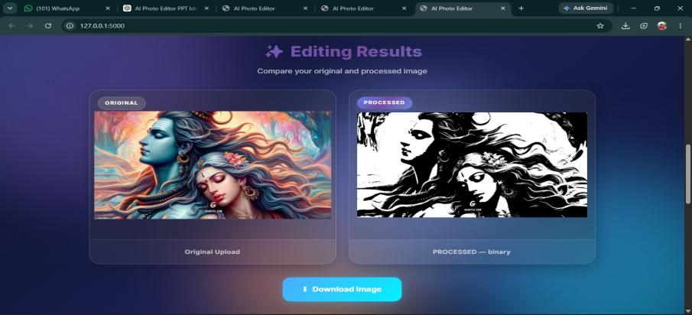

- RGB to Gray :-
Converts a color image into a grayscale image by combining the Red, Green, and Blue color information.
- METHOD :-
cv2.cvtcolor()

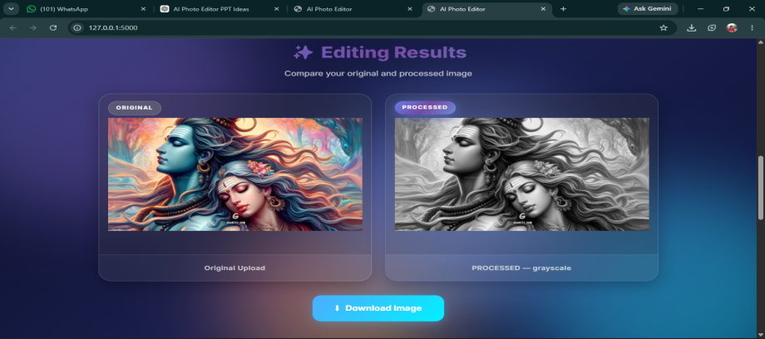

- RGB to HSV :-
Converts an RGB image into Hue, Saturation, and Value (HSV) format, which is useful for color-based image processing. Sharpening: Enhances the edges and fine details of an image to make it appear clearer.
- METHOD :-
cv2.cvtcolor()

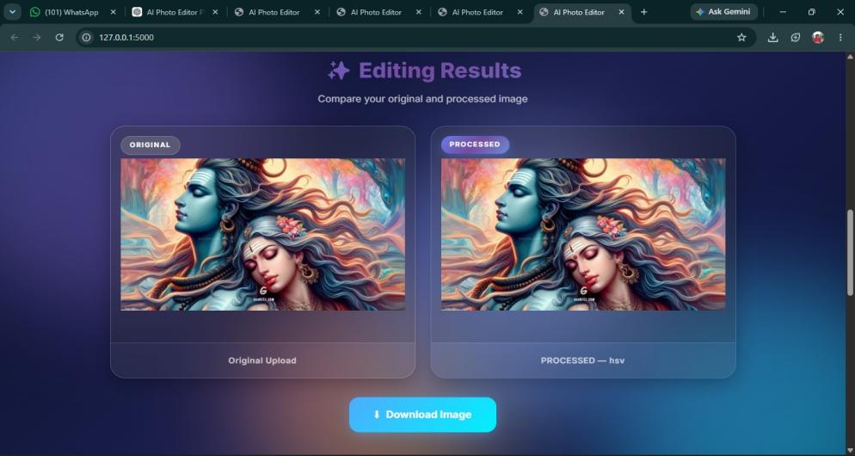

- Edge Detection :-
Identifies the boundaries of objects in an image by detecting sudden changes in pixel intensity.
- METHOD :-
cv2.Canny()

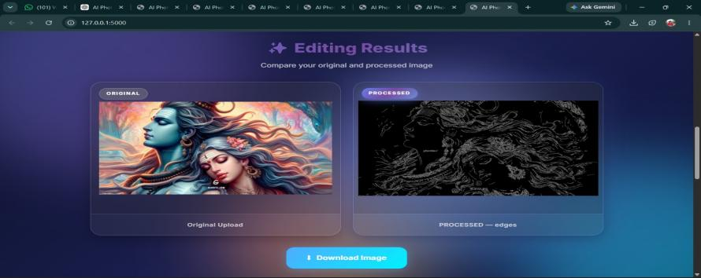

7.Brightness and Contrast:-
Brightness makes an image lighter or darker, while contrast increases or decreases the difference between light and dark areas.
- METHOD :- cv2.convertScaleAbs()
cv2.convertScaleAbs()

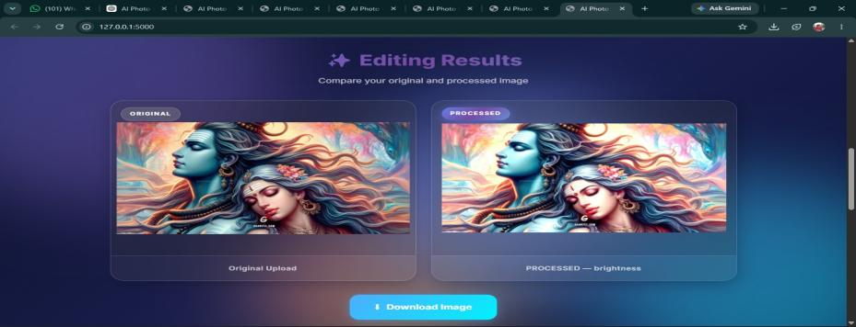

8.Blur :- Reduces noise and fine details.
- METHOD :-
cv2.GaussianBlur()

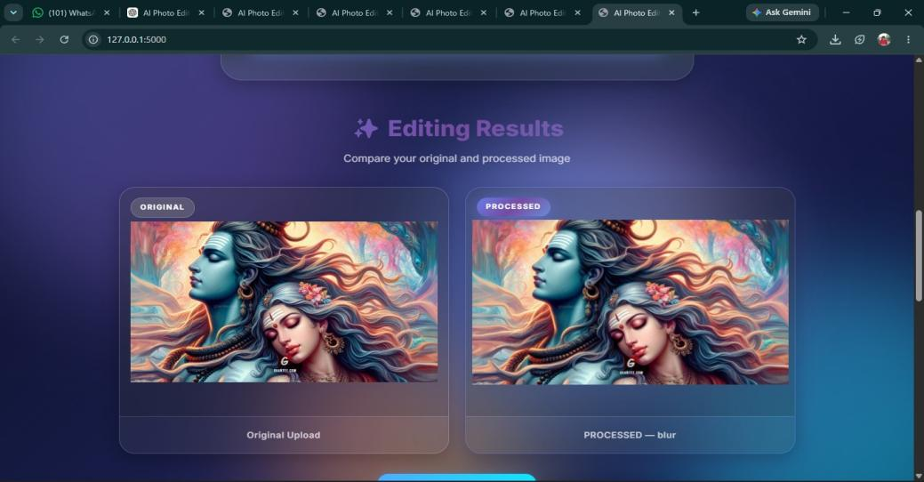

- Sharpen : - Makes edges and details clearer.
- METHOD :-
cv2.Laplacian()

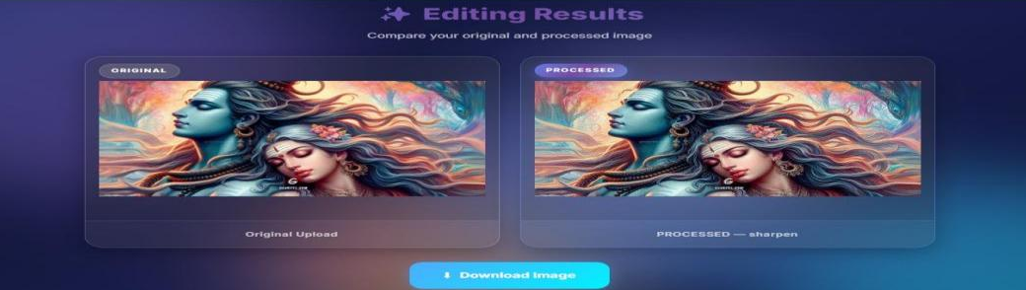

Project Working, Results and Conclusion

- Working of the Web Application :-

- Upload Image:- User selects and uploads an image to the web application.
- Image Processing :- The application processes the image using Python and OpenCV.
- Select Operation:- User selects a required operation such as Grayscale, Binary, HSV, Blur, Brightness, Edge Detection, Sharpen, Dilation, Erosion, Opening, or Closing.
- Apply Method :- The selected OpenCV method is applied to the uploaded image.
Preview Result – The processed image is displayed on the web page for preview.
- Save/Download:- User can save the processed image as the final output.
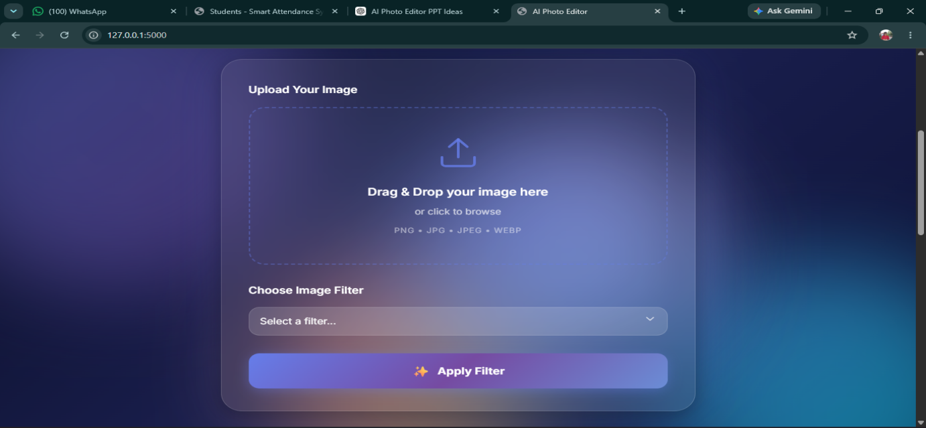

- Results :-
- Simple web-based photo editor developed.
- Multiple image-processing operations work successfully.
- Processed images can be previewed and saved.

- Advantages :-

- Easy to use.
- Saves time and effort.
- Multiple tools in one application.

- Limitations :-

- Limited to basic editing.
- No advanced AI features.

- Future Scope :-

- Add AI background removal.
- Add face/object detection.
- Add more editing features.

